CSC 411 Assignment 3 output

1. Question1) a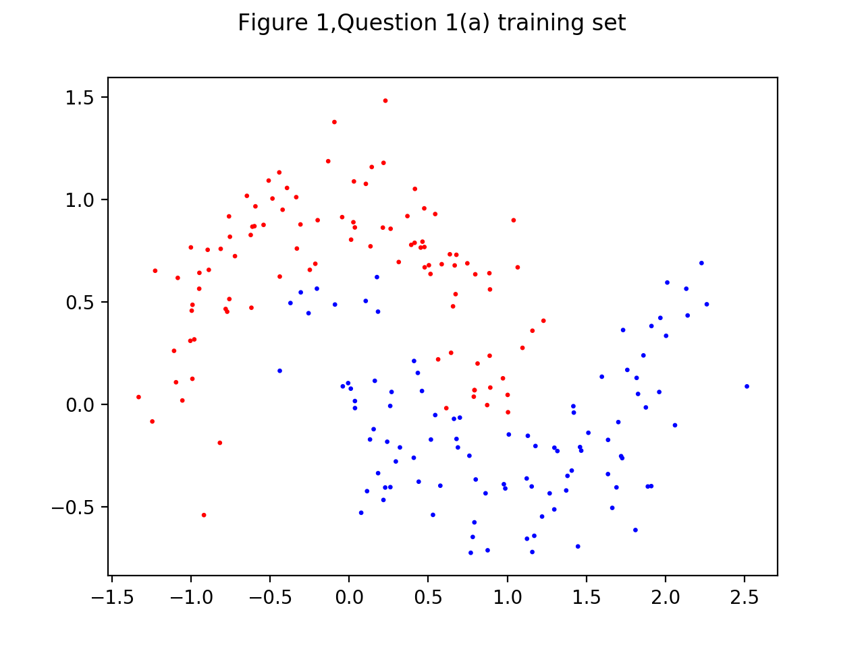

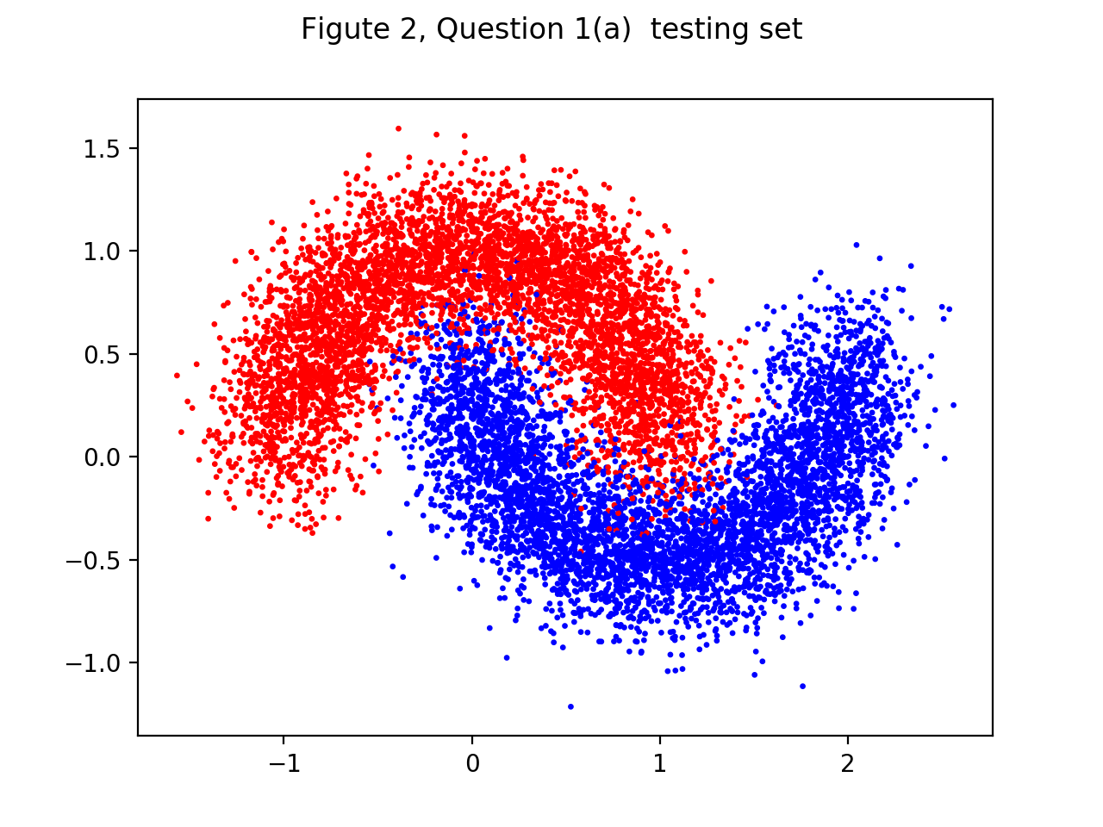

part2) Errors

The error is 0.035400

The error is 0.032100

The error is 0.036000

The error is 0.117200

The error is 0.033800

The error is 0.036500

The error is 0.036600

The error is 0.039200

The error is 0.032900

The minimum error is 0.032100

Graph for part2)

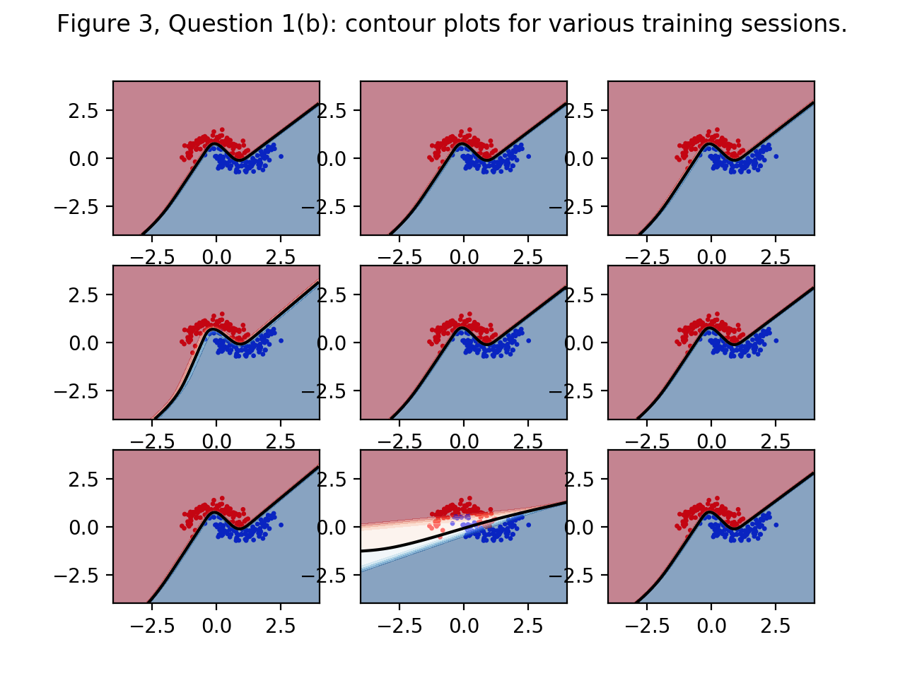

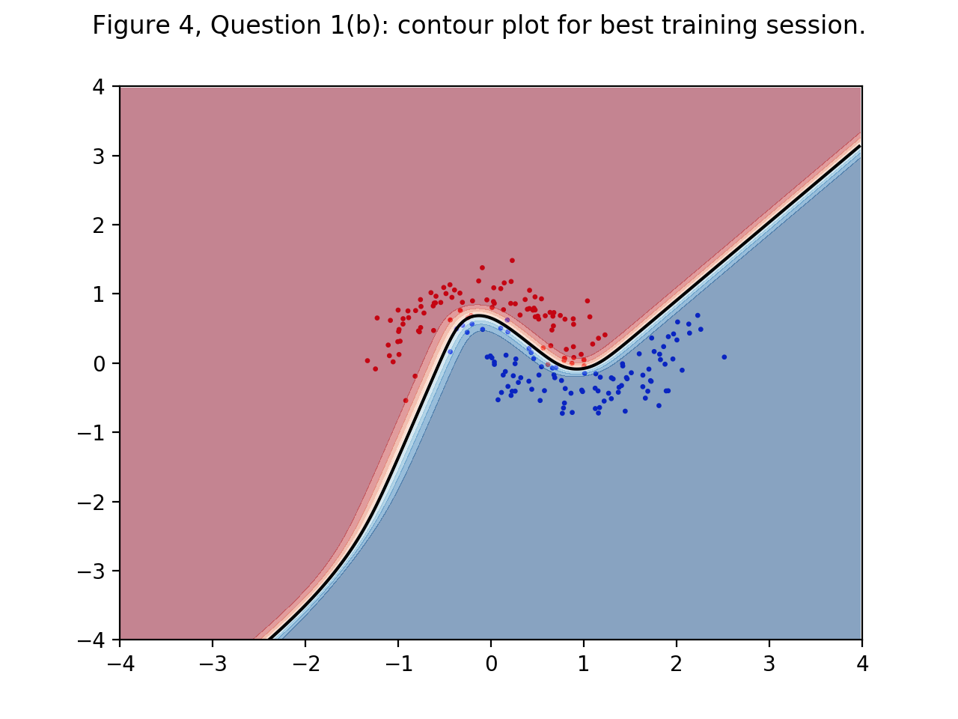

Question 3)

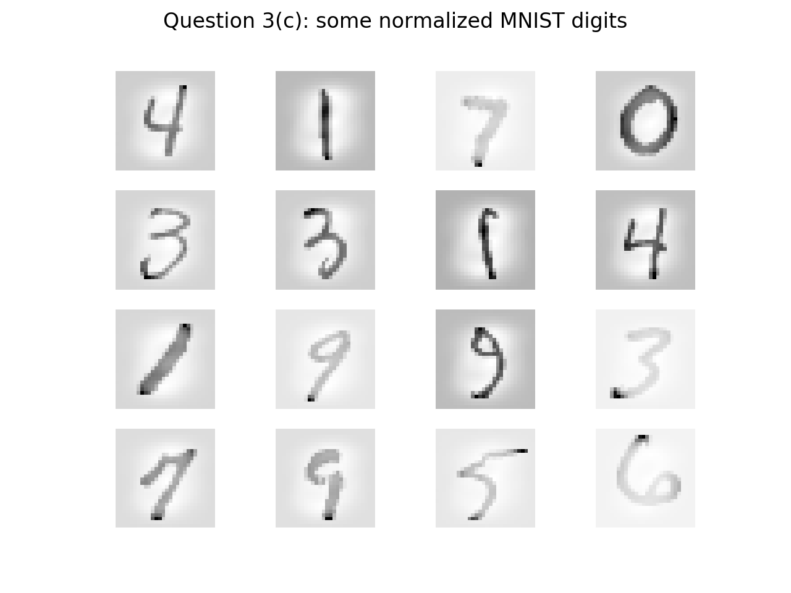

Question 3d) print out

Learning rate =0.700000, momen = 0.010000 alfa =0.030000 : The train error is 0.009150 and the Test error is 0.036100

Learning rate =0.700000, momen = 0.010000 alfa =0.030000 : The train error is 0.006000 and the Test error is 0.034400

Learning rate =0.700000, momen = 0.010000 alfa =0.030000 : The train error is 0.004167 and the Test error is 0.032700

Learning rate =0.700000, momen = 0.010000 alfa =0.030000 : The train error is 0.002967 and the Test error is 0.033000

Learning rate =0.700000, momen = 0.010000 alfa =0.030000 : The train error is 0.002000 and the Test error is 0.032200

Learning rate =0.700000, momen = 0.010000 alfa =0.030000 : The train error is 0.001600 and the Test error is 0.032700

Learning rate =0.700000, momen = 0.010000 alfa =0.030000 : The train error is 0.001083 and the Test error is 0.031700

Learning rate =0.700000, momen = 0.010000 alfa =0.030000 : The train error is 0.000717 and the Test error is 0.031600

Learning rate =0.700000, momen = 0.010000 alfa =0.030000 : The train error is 0.000467 and the Test error is 0.032200

Learning rate =0.700000, momen = 0.010000 alfa =0.030000 : The train error is 0.000517 and the Test error is 0.031800

Learning rate =0.700000, momen = 0.010000 alfa =0.030000 : The train error is 0.000483 and the Test error is 0.031400

Learning rate =0.700000, momen = 0.010000 alfa =0.030000 : The train error is 0.000283 and the Test error is 0.030600

Learning rate =0.700000, momen = 0.010000 alfa =0.030000 : The train error is 0.000500 and the Test error is 0.030200

Learning rate =0.700000, momen = 0.010000 alfa =0.030000 : The train error is 0.000317 and the Test error is 0.031000

Learning rate =0.700000, momen = 0.010000 alfa =0.030000 : The train error is 0.000217 and the Test error is 0.030500

Learning rate =0.700000, momen = 0.010000 alfa =0.030000 : The train error is 0.000133 and the Test error is 0.029900

Learning rate =0.700000, momen = 0.010000 alfa =0.030000 : The train error is 0.000167 and the Test error is 0.029500

Learning rate =0.700000, momen = 0.010000 alfa =0.030000 : The train error is 0.000217 and the Test error is 0.030000

Learning rate =0.700000, momen = 0.010000 alfa =0.030000 : The train error is 0.000283 and the Test error is 0.031300

Learning rate =0.700000, momen = 0.010000 alfa =0.030000 : The train error is 0.000233 and the Test error is 0.030400

Learning rate =0.700000, momen = 0.010000 alfa =0.030000 : The train error is 0.000133 and the Test error is 0.030000

Learning rate =0.700000, momen = 0.010000 alfa =0.030000 : The train error is 0.000217 and the Test error is 0.030900

Learning rate =0.700000, momen = 0.010000 alfa =0.030000 : The train error is 0.000317 and the Test error is 0.030000

Learning rate =0.700000, momen = 0.010000 alfa =0.030000 : The train error is 0.000233 and the Test error is 0.029200

Learning rate =0.700000, momen = 0.010000 alfa =0.030000 : The train error is 0.000167 and the Test error is 0.029200

Learning rate =0.700000, momen = 0.010000 alfa =0.030000 : The train error is 0.000283 and the Test error is 0.028900

Learning rate =0.700000, momen = 0.010000 alfa =0.030000 : The train error is 0.000217 and the Test error is 0.029700

Learning rate =0.700000, momen = 0.010000 alfa =0.030000 : The train error is 0.000300 and the Test error is 0.029500

Learning rate =0.700000, momen = 0.010000 alfa =0.030000 : The train error is 0.000217 and the Test error is 0.029700

Learning rate =0.700000, momen = 0.010000 alfa =0.030000 : The train error is 0.000200 and the Test error is 0.029300

Learning rate =0.700000, momen = 0.010000 alfa =0.030000 : The train error is 0.000133 and the Test error is 0.029900

Learning rate =0.700000, momen = 0.010000 alfa =0.030000 : The train error is 0.000150 and the Test error is 0.029000

Learning rate =0.700000, momen = 0.010000 alfa =0.030000 : The train error is 0.000133 and the Test error is 0.028100

Learning rate =0.700000, momen = 0.010000 alfa =0.030000 : The train error is 0.000133 and the Test error is 0.027700

Learning rate =0.700000, momen = 0.010000 alfa =0.030000 : The train error is 0.000200 and the Test error is 0.028500

Learning rate =0.700000, momen = 0.010000 alfa =0.030000 : The train error is 0.000100 and the Test error is 0.028400

Learning rate =0.700000, momen = 0.010000 alfa =0.030000 : The train error is 0.000117 and the Test error is 0.028900

Learning rate =0.700000, momen = 0.010000 alfa =0.030000 : The train error is 0.002967 and the Test error is 0.031800

Learning rate =0.700000, momen = 0.010000 alfa =0.030000 : The train error is 0.004817 and the Test error is 0.033000

Learning rate =0.700000, momen = 0.010000 alfa =0.030000 : The train error is 0.005100 and the Test error is 0.035400

Learning rate =0.700000, momen = 0.010000 alfa =0.030000 : The train error is 0.002350 and the Test error is 0.031800

Learning rate =0.700000, momen = 0.010000 alfa =0.030000 : The train error is 0.001833 and the Test error is 0.032500

Learning rate =0.700000, momen = 0.010000 alfa =0.030000 : The train error is 0.001217 and the Test error is 0.031500

Learning rate =0.700000, momen = 0.010000 alfa =0.030000 : The train error is 0.001033 and the Test error is 0.031400

Learning rate =0.700000, momen = 0.010000 alfa =0.030000 : The train error is 0.000700 and the Test error is 0.030800

Learning rate =0.700000, momen = 0.010000 alfa =0.030000 : The train error is 0.000483 and the Test error is 0.031000

Learning rate =0.700000, momen = 0.010000 alfa =0.030000 : The train error is 0.000450 and the Test error is 0.031100

Learning rate =0.700000, momen = 0.010000 alfa =0.030000 : The train error is 0.000367 and the Test error is 0.030900

Learning rate =0.700000, momen = 0.010000 alfa =0.030000 : The train error is 0.000300 and the Test error is 0.029600

Learning rate =0.700000, momen = 0.010000 alfa =0.030000 : The train error is 0.000267 and the Test error is 0.030500

Question 3e)result print out(best result)

*Learning rate =0.300000, momen = 0.001000 alfa =0.150000 : The train error is 0.002717 and the Test error is 0.024700*

*Learning rate =0.300000, momen = 0.00100 alfa =0.150000 : The train error is 0.002317 and the Test error is 0.024100*

Question 3f)

I finished the coding but cant wait the result come out

(I don’t kno)

Question 4b)

The difference between predict and predict_proba is

2.63883934137e-33

Question 4c)

I don’t know

Question 4d)

I don’t know

Question 4f)

I don’t know

Question 4g)

I don’t know

Question 4h)

I don’t know